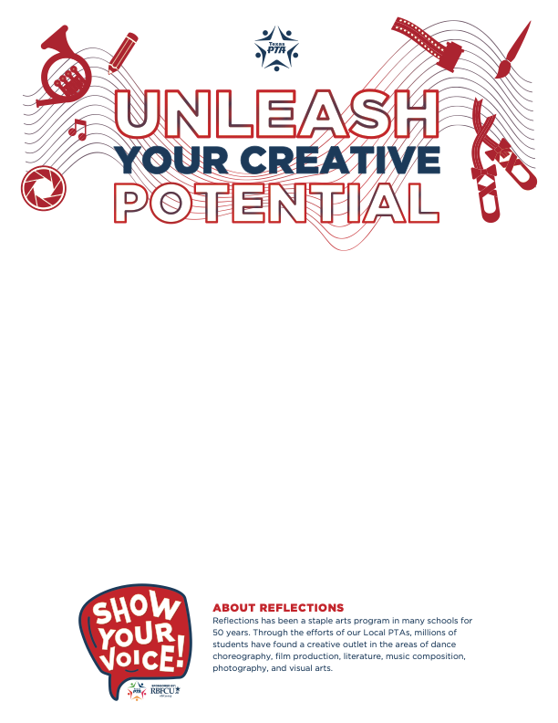

*The arts – and the National PTA Reflections program – support student success and serve as a valuable tool for building strong partnerships in your school community. Celebrate arts learning in your school community with Reflections.*

Express your artistic talent and tell us how you plan to show your voice through Reflections 2022-2023!

Submissions in six artistic categories (*Visual Arts, Literature, Photography, Music, Film and Dance*) are due by **November 4th.**

**Theme: “SHOW YOUR VOICE!”**

Please visit the link for Rules and the Entry form or scan QR code

<https://www.txpta.org/reflections-participation>

Submit in the library between Nov 1st - Nov 4th.

Judging will be held Nov 7th – 11th

Please contact Chetna Mhatre [chetna.mhatre@gmail.com](mailto:chetna.mhatre@gmail.com) or

Allason James [taylorptsapres@gmail.com](mailto:taylorptsapres@gmail.com) for any questions.